I O
America’s Dance!

Powerhouse!!! Percussive Dance combines brilliantly innovative tap, precision clogging, explosive stomp and Irish step into an electrifying interactive educational experience! Director, Brian Bon, a 5 year veteran of the TV show HEE HAW who also appeared on America’s Got Talent, and 15 other variety dance competition television shows, found his passion for clogging was running in to more than a little resistance in terms of interest. That is until he came up with the unique presentation of “percussive dance”—America’s most culturally iconic folk dance. Selected from some of the very best in the country, the dancers in the show are often nationally recognized competitors.

America’s Dance creates an exciting and accessible venue for kids of all ages and backgrounds who might not normally get a chance to experience this rich piece of American culture and entertainment.

Percussive Dance, as we define it, parallels the rich melting pot of diverse cultures that make America great. Immigrants brought the best parts of their cultures to America with them and those cultures began to blend.

Audiences get to see various styles of folk dance and learn where that style originated before finally seeing them all combined in a uniquely American style called “percussive dance.” Additionally, they are left with a solid understanding of the musicality of this style of dance, specifically referring to terms like acapella, percussion, rhythm, and tempo.

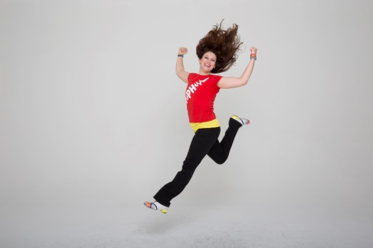

Art Form: dance and music
Style: folk dances (clogging, tap, Irish, step/stomp) and a contemporary blend of those styles;
Culture: American, European, African
DISCU: ACTIVITIES TO ENHANCE THE EXPERIENCE:

Objectives:
- Allow students to experience the excitement of contemporary and folk styles of percussive dance.
- Give basic knowledge of the musicality of percussive dance (making music with our feet/hands/body).
- Give students basic understanding of the geographical/cultural evolution of percussive dance from folk dances/areas around the world.

Vocabulary:
Dance: To move ones feet, hand, and/or body rhythmically, especially to music.
Percussion: The Striking of one solid object with or against another with some degree of force
to make a sound.
Rhythm: Sounds and the space in between them; generally a continuous and reoccurring
beat.
Tempo: The rate or speed of motion, activity or music.
Showmanship: The ability to do things in a lively or enthusiastic way that attracts attention.
Precision: The quality or face of being exact and accurate.
Folk Dance: A type of dance identified with a specific region or culture of the world based on
the way the body is moved, the music danced to, and costuming worn.
Acapella: Music made from the human voice or body without the accompaniment of musical instruments.

Pre and Post show possible review questions:

Musicality:
Percussive Dance is dancing that creates percussive music utilizing only ones hands and feet.
- What is percussion?
- “The striking of one solid object with or against another with some degree of force to make sound.”
- What is rhythm?
- “Rhythm: sounds and the space in between them; generally a continuous and re-occurring beat.”
- What is tempo?
- Tempo: “The rate or speed of motion, activity or music.”
- What does acapella mean?
- Acapella means singing or dancing without musical accompaniment.
- Give example of percussive instruments. (Drums, Triangle, Piano, etc…)
- Do any of the students play percussive musical instruments?

Dance and culture:
- What part of POWERHOUSE: America’s Dance did you find most memorable?
- Why?
- How does this style of dance make you feel?
- Were the dancers emotional connected to the performance?
- What is dance? What is folk dance?
- Have any of the students taken dance classes before? What styles.
- What styles of folk dance did Powerhouse!!! combine to make their contemporary American Folk dance?
- Irish Step Dancing/Riverdance
- Tap and Stomp(European folk dances/African dances combined),
- Clogging
- What are folk dance rules or traditions?
- Folk dance traditions are styles or unique characteristics of a dance that develop from its cultural origins.
- Ask the students if they have family members from different counties/backgrounds.
- Ask if the students take any type of dance lessons and have them share about their dance lessons. Discuss the backgrounds of the type of dances they bring up.

Projects/Games
Make your own tap shoes
Items needed: old shoes, quarter sized washers, duct tape or strong glue.
Simply glue or tape the washers in the following position on the shoes to create your own tap shoes.
Rhythm Game
Have them play a rhythm name game. For example, they sit in a circle. They do the following pattern of percussion sounds with their hands.
- Slap slap clap snap;
- Count to 4 while doing this.
- Once they get that they can substitute a name for the number 4.
- The name that is called has to go next and call another name.
- All of this is done in rhythm at a certain tempo.
- Speed it up for more fun!
Circle Dance:
Form a circle and allow the students to go in the middle either one at a time or in small groups and demonstrate their favorite styles of dance. After this is done they can do a group dance like the Hokey Pokey or Cha Cha Slide.

YouTube videos to watch for reference:
Tap Dogs
https://www.youtube.com/watch?v=oRUdvu3Qo-E
Riverdance
https://www.youtube.com/watch?v=SevfZ5gCUnY
Rhythm Circus
https://www.youtube.com/watch?v=gcbu0pWtJhg
POWERHOUSE!!!
https://www.youtube.com/watch?v=Cok7FdxMaeo
https://www.youtube.com/watch?v=R2gyuuGLMHQ
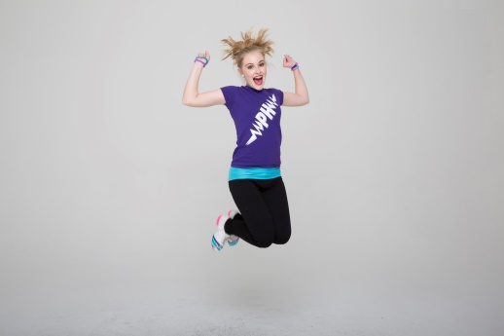
About the Director:
Director, Brian Bon, is a nationally recognized competitor, instructor and performer with 1000's of award titles, more TV/film credits than any other clogger in the country & 39 years of teaching & performing experience private studios, universities, and in the public school system. Mr. Bon also has a BA in Theatre and English. Current arts affiliations include Segerstrom Center for the Arts “ARTS TEACH” assembly/workshop roster, All the Arts for All the Kids (Fullerton School District), Children’s Creative Project, Sulphur Springs School District and more.

